Unitarian Universalist Congregational Society of Westborough
64 West Main Street
Westborough, MA 01581
phone: 508-366-2635
Email: uucswestboro@verizon.net
Website: www.uucsw.org
Facebook: Unitarian Universalist Westborough
Twitter: UU Westborough (MA)@UUWestborough

WEEKLY UPDATE
08/09/2017

SUNDAY AUGUST 13 - WORSHIP SERVICE: 09:30 AM –

PLEASE NOTE: SUMMER SCHEDULE TIME – 9:30 AM

Harry and UU For All Ages – Phyllis Samara & Jenna Kyes, Service Leaders.

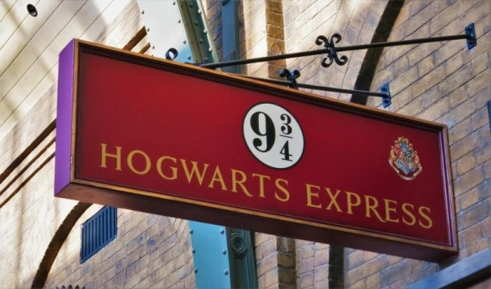
Join us Sunday as Phyllis Samara and Jenna Kyes lead a fun, family-friendly wizarding experience based on the popular Harry (Potter) and UU curriculum. Grab your wand and join us to find out how social action can destroy Horcruxes.

PLEASE NOTE: Summer Services begin at 9:30 AM and take place in the air conditioned Chapel. Please enter through the Ruggles Street door and use the lift or stairs to the upper level.

BEVERAGES WITH REV BEV – Tuesday August 15th –
10:30am – 12 @ Panera in Westborough

Join Rev Bev for a cup of coffee or tea and casual conversation.

She will be at the Panera in Westborough (Westborough Common) from 10:30 am to 12:00 pm.

COME CELEBRATE 300 YEARS TOGETHER!
Westborough’s TOWN BIRTHDAY PARTY SUNDAY SEPTEMBER 10th

As you hopefully have already read in previous emails, UUCSW is CELEBRATING 300 years as a congregation along with the town.

Our annual In-Gathering Service will be held as usual at 10:30 am with a planned ending at 11:15 to allow for folks to move cars since Main Street will close at 11:30 am for the 1 pm parade.

UUCSW is planning to:

1. March in the parade, carrying a banner and wearing UU T-Shirts

2. Host a lawn party for those who want to watch the parade rather than march.

What you can do to ensure a successful and fun day:

1. Please RESPOND TO THE DOODLE POLL and let us know whether you would like to: MARCH in the PARADE or MAKE MERRY ON THE LAWN. http://doodle.com/poll/56usnch5ei5y5sp2

2. Pitch in for fun! Look for information coming from some of the organizers listed below or even better call and volunteer now for whatever you are most interested in helping with.

PLANS thus far:

MARCH carrying a banner in the parade wearing UU T-shirts. WE WOULD LOVE A BIG CROWD participating in this way. OR

MAKE MERRY- enjoy a lawn party on the front lawn of the church with family friendly events. We are hoping to attract folks from the community too!! Invite your friends and neighbors to join us.

WATCH for information SOON about PRE-ORDERING UU T-shirts.

CONTACTS for volunteering:

Contact Jenna Kyes if you can bring/help with lawn games and face painting
Contact John Metzger or Jerry Breecher for any parade-related questions
Contact Lisa Shumway if you can bake chocolate chip cookies or donate 8 oz water bottles
Contact Kim Hall if you want to help sell popcorn and lemonade.
Contact Sharon Barrett if you can help with advertising
Contact Ann Maloney if you can help with plans for placing a geocache or time capsule.
Contact Rev Bev (RevBevW@gmail.com) for contact information for the above people.

